Community Resource Fair!!
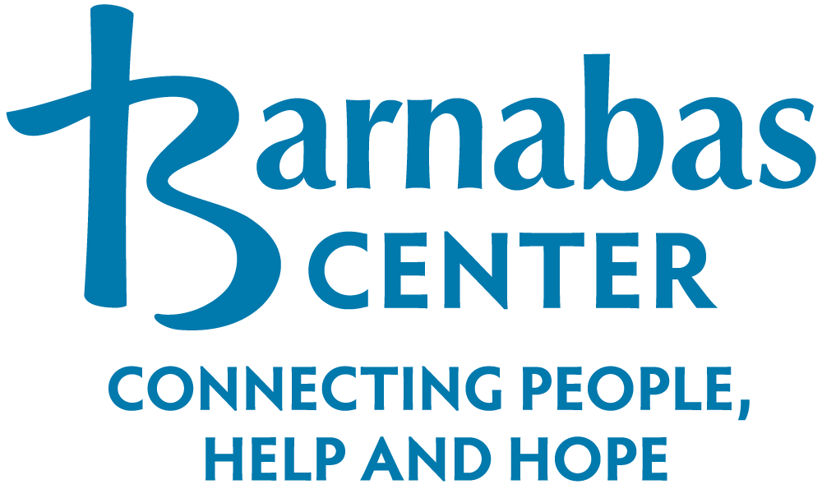
When: Thursday, April 25th,2024
Time: 10:00 am – 12:00 pm
Where: Barnabas Center
1303 Jasmine St
Fernandina Fl 32034
Light refreshments will be provided
Come learn more about:

FSCJ – Florida State College of Jacksonville
Workforce Education Department
Youth Crisis Center
Crisis Care, Mental Health Counseling for children, teens, young adults, and their families.
Nassau County Emergency Management
Emergency Preparedness

